Rough Figures Outlines Chapters 3 and 4 and 4.5
Chapter 3 – Monkey behaviour in BDM
Figures0x-y – task layout (and for bcb too probably separate figure)
What the monkey sees when doing the BDM. Maybe also some more guff on monkey weight over time. Just generic table setting stuff.
Figure 1 – Mean bids over all?/recording? Sessions split by 3 levels boxplot
For each monkey, over the population the mean mean bid is rank ordered. Can see overlap over population tails but can pretty clearly see rank ordering
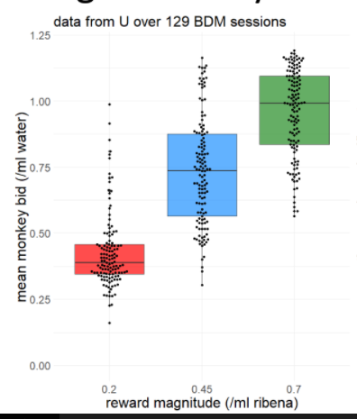
Figure 2 – rank ordering is significant within single session
Wilcoxon test of between levels on a single day, show number of days that have significant differences in mean bid between levels. Maybe separate this out over time to see if theres a temporal patten (e.g. he high-medium bids were all close together one summer then separated again). Either here on in a separate figure also show the spearmans rho coefficient by bid level by day (2nd graph here) .
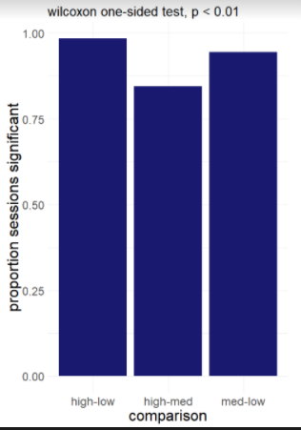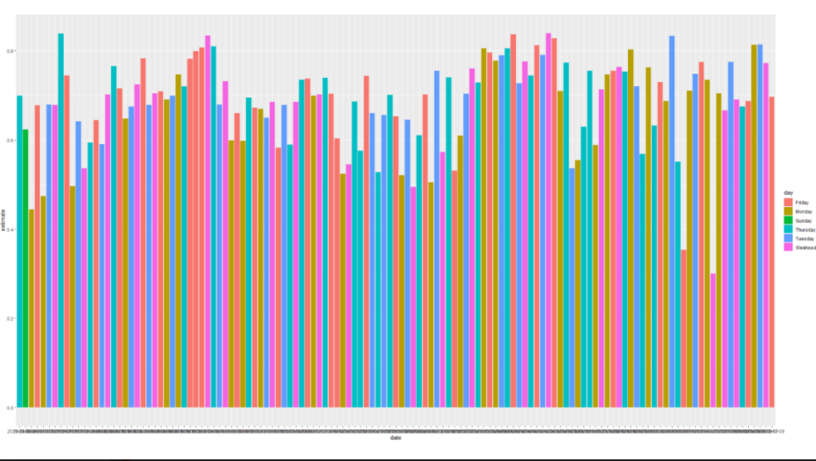
Figure 3/Figure s1 – Change in rolling average bids over a whole day
Show how bids change over a single day for each monkey- bidding is not static over the session for the same good. Probably in supplementary have a massive plot of how bids changed over all days. Extra graph showing how quickly the pairwise tests reach significance across single sessions (2nd graph). Maybe also include your EWCBR plot on distributions by day though Im not a huuuuge fan of it
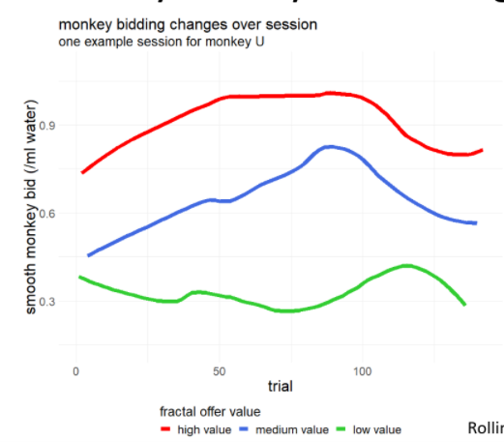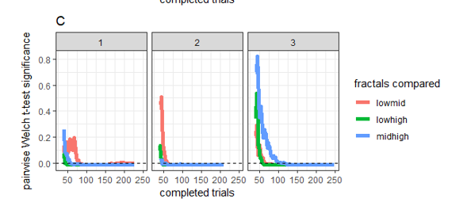
Figure 4 – variable importance model of monkey bidding
Xgboost/LASSO/random forest/glmnet/etc. model of monkey bidding highlighting important factors for monkey bidding. Maybe even a supplementary for comparing different models (esp one with variable shrinkage and one without). Highlight which are the important variables (magnitude obviously, and also satiation). Potentially make supplementary into an appendix showing e.g. how importance changes over time for variables. ROC on test/train, etc.
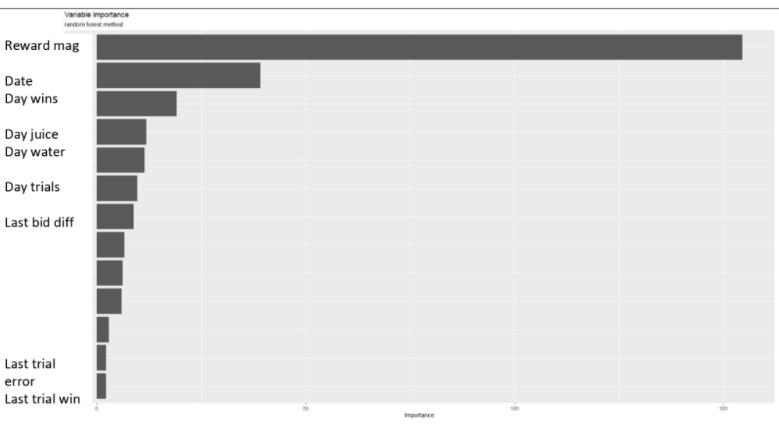
Figure 5 – Binary Choice Data of monkey
Show monkeys can do binary choice. Messy single days and averaged together to get logistic curves of choice and can pick out indifference points. Maybe simple random utility model plot to show ‘average’ indifference across levels.
Figure 6 – How do monkeys BDM bids differ by ‘inferred’ value using indifference point over session
Take indifference point/average indifference points and calculate for each session how ‘suboptimal’ each monkeys bids are. I.e. assume indifference point is ‘optimal bid’ and calculate payoff per session per monkey as percentage of maximum payoff (see economics chapter). Figure 4 of Alaa’s paper. Maybe also figure 3ef on Alaa’s paper (regress monkey bid against Binary Choice indifference point predicted bid per session).
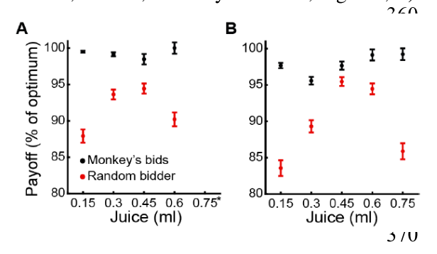 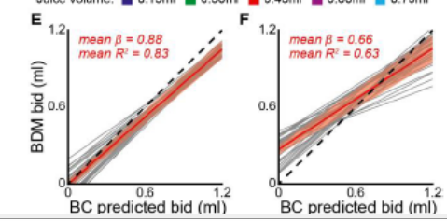
Figure 7 – Variable importance for monkey doing Binary choice task
Same as before- idea to show that other variables (e.g. side bias) also significantly affect bcb – binary choice and bdm are not task invariant in my opinion. Could switch this and figure 6 as I think figure 6 should be nearer the ‘conclusion’ of the chapter. Random utility modelling of satiety in binary choice
Other appendix figures (stuff that I don think needs a whole figure but is task related data)
- Reaction time and vigor of bid in BDM and reaction time vs. variables e.g. final bid, reward magnitude, etc.
- Reaction time in BCB and vigor of bid in BCB. Average ‘bid’ location on the Bcb
- Mayyybe some of the training data we have especially the forced bid data

Chapter 4 – ephs of bdm (and bcb)
Figure 0 – dopamine recording locations
Xrays of two monkeys for chamber positioning and x/y grid graph showing where n neurons were recorded from (included equivalent from marks thesis below)
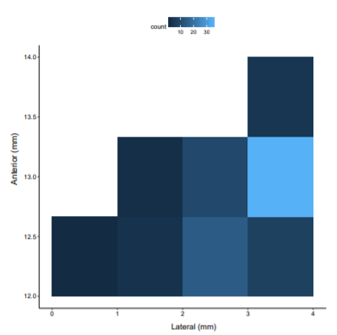
Figure 1 – dopamine neurons show positive rpe to unpredicted reward
Show responses to free reward key press. Dopamine cells were classified using criteria xyz, starting with identification using response to unpredicted reward…
Figure 2- more dopamine classification
Dopamine neurons are classified by response to fixation cross, length of cell trace (show average trace), and post stimulus spike histogram. We recorded n cells…
Figure 3 – dopamine encodes value of rewards presented
Average traces of cells at the fractal offer (+ raster plot above/below/side). Neurons shows increased z firing rate to higher magnitudes of reward
Figure 4 – dopamine neurons encode rpe of profit on trial
Traces/etc. of dopamine cells z firing at the win/lose epoch split by when monkey wins and when they loses a trial (maybe also split by reward level here).
Figure 5 – dopamine and payout of trial
Same as above but for when the monkey actually gets the juice/water. Fully predicted by result of trial. Might split out here results when we do get a large RPE here and see what is happening with bids/result of trial on those trials (e.g. is it when the two bars overlap so monkey is unsure what hes getting)
?Figure 6? – dopamine behaviour during bidding phase
Probably will move this one around to be in ‘task epoch order’ though I also quite like going in order of most obvious (DA encodes fractal magnitude) least obvious (da behaviour during bidding). Not strong opinions either way. We seem to get an RPE when bidding starts (being able to bid is rewarding). Does DA activity change/ ‘ramp up’ during bidding as bid approaches optimality? (as with fig 5- potential to split this out into two figures if something interesting is going on [which I think is the case with this epoch – see EWCRB slides])
Figure 7 – DA split by reward level and bid
Does dopamine predict the monkeys bid. Show split by nths (of bidding range or of monkeys bids per level/not by level) and show regression of dopamine activity at the fractal offer against final bid.
Figure 8 – DA split at win lose split by monkey bid/computer bid/profit at winlose
Same as with figure 7 but now splitting the results of trial by the monkey bid/ computer bid/ profit/utility at the win lose point and doing the regression
Figure 9 – the EWCRB figure of the two regressions of bid ~ fractal DA and result ~ winlose DA
The two axes figure hopefully showing lots in the bottom right corner

Chapter 4.5 – modelling DA: stupid to (maybe) smart approaches
(all of these could in theory be wrapped back into chapters 3 and 4. I kinda like having it split out at the end so it’s like “look we have firm no-stats-trickery results in chapters 3 and 4, here is where we push the boat out a little” but your mileage may vary)
Figure 1 – predict bids using variable importance
Chapter 3, fig4 modelling of monkey bid by loads of latent factors. Use this to predict what the monkeys inferred utility/bid is per trial and regress this against actual bid
Figure 2 – simple RL model predicting monkey utility by trial
Update monkeys utility from previous days mean bid by trial and regress against bid
Figure 3 – DA split by reward level and predicted bid
If we use the predicted bids instead of actual bids does it regress better against the firing rate of dopamine at the fractal offer? Tenuous to justify this buy would be interesting
Figure 4 – Really stupid approach to Dabney et al 2020
We in theory could model ‘optimistic’ and ‘pessimistic’ dopamine neurons by regressing their response to the expected payoff given the monkeys bid (see chapter 2 appendix 3) and regress DA firing of results above expected value and below expected value and see if there is asymmetry in the betas
